Information for Summer Program Registration 2026!
We are excited to announce that registration for our 2026 Summer Program is now open! We have planned a fun, engaging, and supportive summer experience that offers a mix of structured activities, recreation, learning opportunities, and themed weekly events for the children and youth in our program.
Our Summer Program will include:
- Daily recreational activities
- Weekly themed programming
- Arts and crafts
- Outdoor games and adventures
- Skill-building and social-emotional learning opportunities
- Special events shown in our activity calendar
To help you plan ahead, we have attached our Summer Activity Calendar, which outlines the themes and scheduled activities happening each week. Closer to the summer, our lead staff will reach out to confirm your requested dates, and will send a more detailed activity calendar with what they plan for each day!
Registration Information
To register, please complete the online registration form using the link below:
👉 Summer Program Registration:
Summer Program 2026 Registration – Fill out form
Please submit your registration as soon as possible, spaces are limited and will be filled on a first-come, first-served basis. Make sure you choose the option to save your responses so you can refer back to them when we confirm your spot. You will hear from us again in May when our summer program leaders start for confirmation of care.
If you have any questions about the program, the calendar, or the registration process, please feel free to reach out—I’m happy to help.
We look forward to a fun and meaningful summer with your child(ren)!

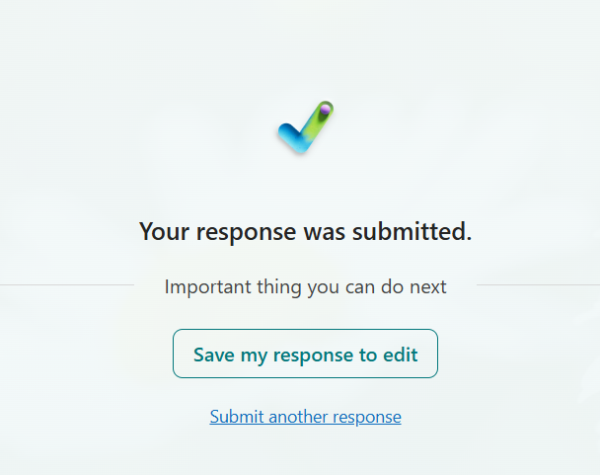
Once you have finished your Microsoft form, please save a copy for your records. The screen to do so looks like this:

Field Trip/Outing Calendar (subject to change! More details closer to summer!)
